Activity | Details
Sketch a map of your house and garden. Hide something somewhere for a family member to find. | Draw your map neatly. Try to include a key and label it clearly.
Create your own classification key on a topic of your choice. | Make sure your classification key is drawn neatly and uses the correct punctuation. Think back to our work in computing and science for ideas. Use neat colouring and pictures.  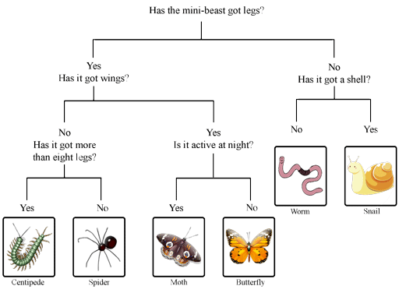
Write your own fantasy story based on a topic of your choice. | Show off your English skills and use all of the features we have taught you to include this year eg. speech, fronted adverbials, conjunctions, noun phrases etc.
Create your own pointillism inspired picture using felt tips or paint. | 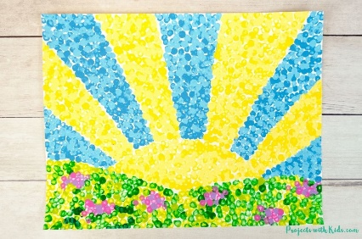  Use the correct technique and bright colours to make your picture stand out.
Research a county or city in the United Kingdom. | Write about some of the human features (buildings, man-made structures, population) and physical features (rivers, lakes etc.).
Create a poster on all the phrases that you can remember from French lessons this year. | Try to use the correct spellings if you can. Include pictures and colours.
Due in 7th July 2023

