Our Question
What does the U.K. trade?
Key Vocabulary
trade | Buying and selling goods and services.
import | Goods or services purchased from one country and brought into the U.K.
export | Goods or services made in the U.K. and sold to another country.
goods | Items that can be bought and sold. Sometimes they are called products.
global | Around the world.
fair trade | A way of buying goods designed to make sure that the producers of these goods in developing countries are pad a fair and stable price for the goods that we buy from them.
globalisation | The spread of trade and ideas worldwide.
global supply chain | The different places a product and its parts come from, and travel to, on its way to the consumer (the person who is buying the product).
multinational | Something that operates in more than one country. A multinational business is based in more than one country.
economy | The word used to explain how much money is made and spent in a particular area. This could be within a country or across the world.

Y5/6 Trade
The children find out about how goods and services are traded around the world. They will explore the UK's trade links today and in the past, finding out about goods imported and exported and the methods of transport used. Through a more detailed look at one of the UK's trade partners, the children will learn about the benefits of trading internationally, as well as the risks to this area. The children will also learn about fair trade and why it is important in a global market.
Background Knowledge
Children will build on previous knowledge from Year 3 about the UK. They can locate the UK on a world map and know that the River Thames was significant in trading goods in the past.
Trading with El Salvador
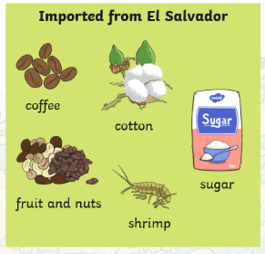
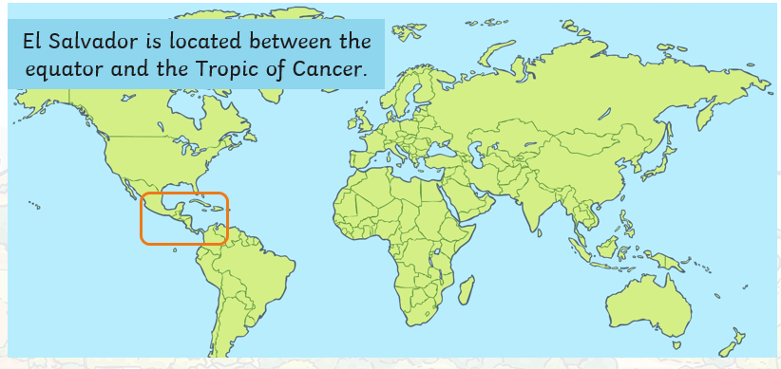
Fair Trade

There are lots of steps in the trade process but people involved are not always paid equally or fairly. Fair trade exists to make sure that people are not exploited.
Look out for the fair trade logo when buying things so that you know that people have been paid fairly for their work.
U.K. imports and exports
The UK trades a lot of goods and services. Some of the goods the UK exports are: scrap iron, whisky, tartan kilts, medicines, aircraft parts, cars, computers, oil and gas.

Some of the goods the UK imports are: coffee beans, bananas, medicines, aircraft parts, cars, computers, oil and gas.
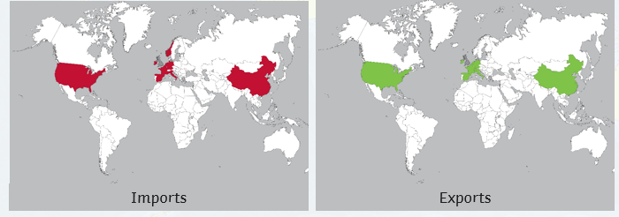
Key Facts
- The U.K.’s main trade partners are: USA, Ireland, Spain, France, Germany, Italy, Netherlands, Belgium, Norway and China.
- Some of the main goods imported to the U.K. are: computers, cars, oil, medicines, plastics and clothing.
- Coffee, cotton, sugar, fruit and shrimps are imported to the U.K. from El Salvador.
- McDonald’s trade in 122 countries. There are 19 in El Salvador and 1274 in the U.K.
- Trade has changed a lot through history. This is partly due to developments in transportation but also due to the expansion of the British Empire.
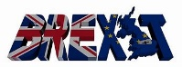
- was the withdrawal of the U.K. from the European Union (EU) on 31st January 2020. This has caused disruptions between U.K. / E.U. imports and exports.

